**Proposed Title**

**Neural Style Transfer for 3D Model**

**Field Of Invention**

Neural Style Transfer is a technique that uses deep learning algorithms to transfer the artistic style of one image to another. This technique has been used primarily in the area of 2D image processing, but it can also be applied in the area of 3D modeling.

In 3D modeling, neural style propagation can be used to create textured 3D models with a particular style or aesthetic. For example, you can use Neural Style Transfer for mapping to make your character's 3D model look like a watercolor painting or a comic book illustration.

Applying neural style mapping to a 3D model involves the process of rendering the 3D model into a 2D image, applying the neural style mapping algorithm, and then mapping the style mapping onto the 3D model. This process is computationally intensive and requires specialized hardware and software tools.

Neural style transfer in 3D modeling has great potential for creating visually appealing and unique 3D models, especially in industries such as games, animation, and visual effects. However, much research and development is required to make the process more efficient and practical in real-world applications.

**Background (Reason to work)**

There are several possible backgrounds to the development of neural style transfer of 3D models. One reason for this is the desire to create visually appealing and unique 3D models for a variety of uses. Applying a certain visual style to a 3D model makes it stand out from other models and makes it more appealing to the viewer. Additionally, this technique can save time and resources when creating 3D models by automating the styling process. Another reason is the potential use of this technique in the development of video games and virtual reality environments. In such environments, creating an immersive and visually interesting environment is essential to engaging users. Finally, in the field of 3D printing, this technology can be used to create unique and visually appealing designs for various products.

**Objective**

1. Generate stylized 3D models fast and efficiently by transforming 2D image styles into 3D models using neural networks.
2. Create visually appealing and unique 3D models with a specific visual style that can be used in various applications such as video games, virtual reality and 3D printing.
3. By enabling artists and designers to easily experiment with different visual styles and create new and original designs, it provides a powerful tool for exploring new possibilities in 3D modeling.

**Figure/Model (Flowchart)**

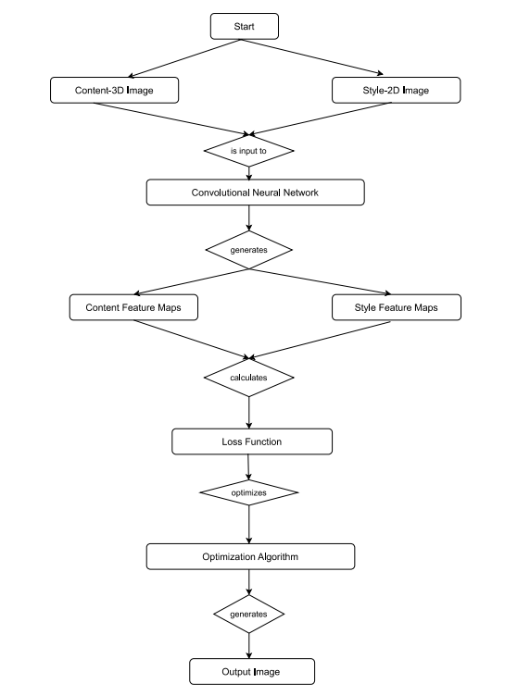

**ER-Daigram**

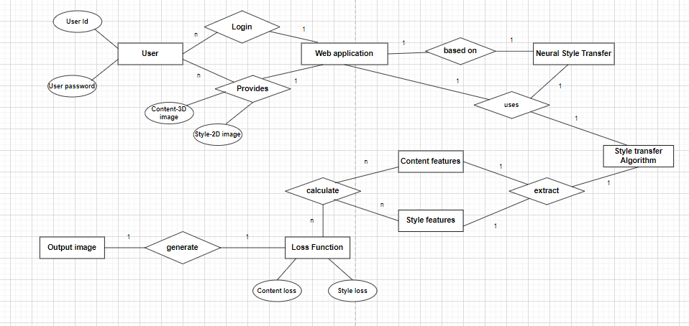

**Claims (novel/innovative idea)**

In traditional neural style mapping, this technique allows you to merge the content of one image with the style of another image. This process is performed using a convolutional neural network (CNN). This is a special type of deep learning model designed to process and analyse visual data. However, in our proposed model, the focus is on extending neural style transfer to 3D objects.

Our 3D Neural Style Transfer model aims to apply visual styles from 2D images to 3D models, pushing the limits of what is typically achievable with traditional style transfer techniques.

One of the main claims of neural style transfer of 3D models is the ability to create visually compelling and unique stylized 3D models in a relatively short amount of time. This is because we can use this technique to transfer the style of the existing 2D image of him to the 3D model instead of creating a new style from scratch. Additionally, different styles and textures can be applied to one 3D model using neural style transfer, allowing for more creative freedom and experimentation.

**Apparatus/Technology Used (Hardware / Software)**

Some hardware tools commonly used in neural style transfer for 3D models include:

1. High Performance GPU (Graphics Processing Unit): These are specialized processors designed to handle complex computations related to graphics rendering, machine learning, and AI algorithms. Efficient transfer of neural styles in 3D modeling requires a high-end GPU.
2. Cluster computing: Cluster computing is a technology in which multiple computers work together as a cluster to perform large-scale computation. This is useful for large neural style transfer projects.
3. Cloud computing: Cloud computing platforms such as Amazon Web Services (AWS), Google Cloud Platform, and Microsoft Azure provide access to high-performance computing resources that can be used for neural style propagation in 3D modeling.
4. Workstations: High-performance workstations with powerful CPUs, large amounts of RAM, and high-end GPUs can also be used for neural style transfer in 3D modeling.

Some software tools commonly used in neural style transfer for 3D models include:

1. learning frameworks: Deep learning frameworks such as TensorFlow, PyTorch, and Keras provide the necessary tools to implement neural networks and perform style transfer. These frameworks include pretrained models and libraries for neural style transfer.
2. 3D modeling software: 3D modeling software such as Blender, Maya, and 3ds Max Deep are commonly used for 3D modeling and animation, and can also be used to transfer neural styles. These software tools provide the interfaces necessary to import, render, and export 3D models.
3. Image processing software: Image editing software such as Adobe Photoshop can be used to prepare images for style transfer. These software tools give you the image editing tools you need to adjust brightness, contrast, and colour balance to achieve the desired effect.
4. Neural style transfer software: There are several software tools specifically designed for neural style transfer. Neural-Style, Artisto, and DeepArt. These software tools provide an interface for importing images, selecting the desired style, and transferring styles.

**Abstract:**

Neural Style Transfer is a widely used technique for transferring the style of one image to another. Recently, there has been growing interest in extending this technique to 3D models. The goal of neural style transfer of 3D model is to create a stylized 3D model which has the same visual style as a given 2D image. This technology has many applications in areas such as video games, virtual reality, and 3D printing.

To achieve neural style transfer on the 3D model, a neural network is trained to learn the style of a particular 2D image. This is typically done using a pretrained convolutional neural network (CNN) such as VGG or ResNet. The network is trained to minimize the style difference between the 2D image and the randomly initialized 3D model. VGG or ResNet is used to optimizing the parameters of the 3D model to minimize a loss function that measures the difference between the original 3D model and a stylized version of the model.

One of the main challenges in propagating neural styles in a 3D model is representing the 3D model in a way that the neural network can handle. One approach is to use mesh to represent 3D models. A collection of vertices, edges, and faces which define the shape called mesh of the model. Meshes can be converted to 2D images using techniques such as raycasting and voxelization. Another approach is to use a volumetric representation of the 3D model like occupancy grid or signed distance function.

Despite its challenges, neural style transfer of 3D models shows promising results in generating stylized 3D models with different visual styles. Future research in this area could focus on developing more efficient representations of 3D models that can be used in neural networks, and exploring new applications for this technology in areas such as architecture, product design, and art.

**End User:**

Neural Style Transfer end-users for 3D models may vary depending on the specific application. Here are some examples:

1. Video game developer: Game developers can use this technique to quickly generate a stylized 3D model of him for their game. By applying a 2D concept art or illustration style, game developers can create visually stunning environments and characters that match the artistic direction of the game.
2. Virtual Reality Designer: In the field of virtual reality, neural style transfer in 3D models can be used to create an immersive environment with a specific visual style. For example, designers can use this technique to create unique and visually appealing styles of virtual museum exhibits.
3. Product designer: 3D printing allows you to use neural style transfer to 3D models to create unique and visually appealing designs for a variety of products. For example, product designers can use this technique to create custom phone cases with a specific visual style.
4. Artists and Designers: Artists and designers can use this technique to create stylized 3D models of him for various applications such as animation, illustration, and sculpture.

Overall, anyone interested in creating stylized 3D models can benefit from using Neural Transform.

**Advantage:**

1. Artistic freedom: 3D Neural Style Transfer allows an artist to apply a unique artistic style to their 3D model, giving them more creative freedom to create visually appealing and expressive works of art.
2. Time Saving: 3D Neural Style Transfer can significantly reduce the time required to create visually appealing 3D models. Traditional techniques require manual texturing and shading, which can be time consuming and labor intensive. 3D Neural Style Transfer automates this process, reducing the time and effort required.
3. Flexibility: Propagating 3D Neural Styles is very flexible and can be used to apply a variety of artistic styles to your 3D model, including painting styles, photography styles, and abstract styles. This flexibility allows artists to create their own highly customized 3D models.
4. Cost Saving: The traditional 3D modeling and texturing techniques can be expensive and require specialized software and hardware. 3D neural style submission can be implemented using standard deep learning frameworks, thus reducing implementation costs.
5. Improved visual quality: 3D neural style can enhance the visual quality of 3D models and provide users with a more immersive and visually appealing experience. This is especially useful in the entertainment industry where visual quality is a key factor in creating an engaging and memorable experience for the audience.

**Summary/ Conclusion**

In summary, neural style transfer of 3D models is a promising technique that can map 2D image styles onto 3D models. The technique relies on using a neural network to learn the style of 2D images and applying it to the 3D model. The resulting stylized 3D models have many uses in areas such as video games, virtual reality, and 3D printing. The transmission of neural styles of 3D models could revolutionize the way 3D models are created and designed, opening up new possibilities for creativity and innovation.

**Authors List Including Name, Email, E-Sign**

Name Email E-Sign

Akash Goel(Guide) [akash.goel@kiet.edu](mailto:akash.goel@kiet.edu)

Palak Singh [palaksinghps8406206@gmail.com](mailto:palaksinghps8406206@gmail.com) 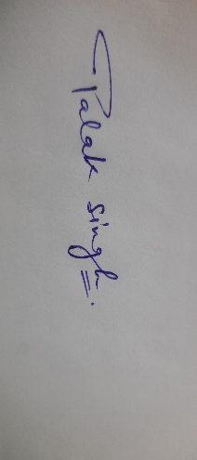

Ragini Rani [raniragini8848@gmail.com](mailto:raniragini8848@gmail.com) 

Kalash Jain [kalashjain171@gmail.com](mailto:kalashjain171@gmail.com) 